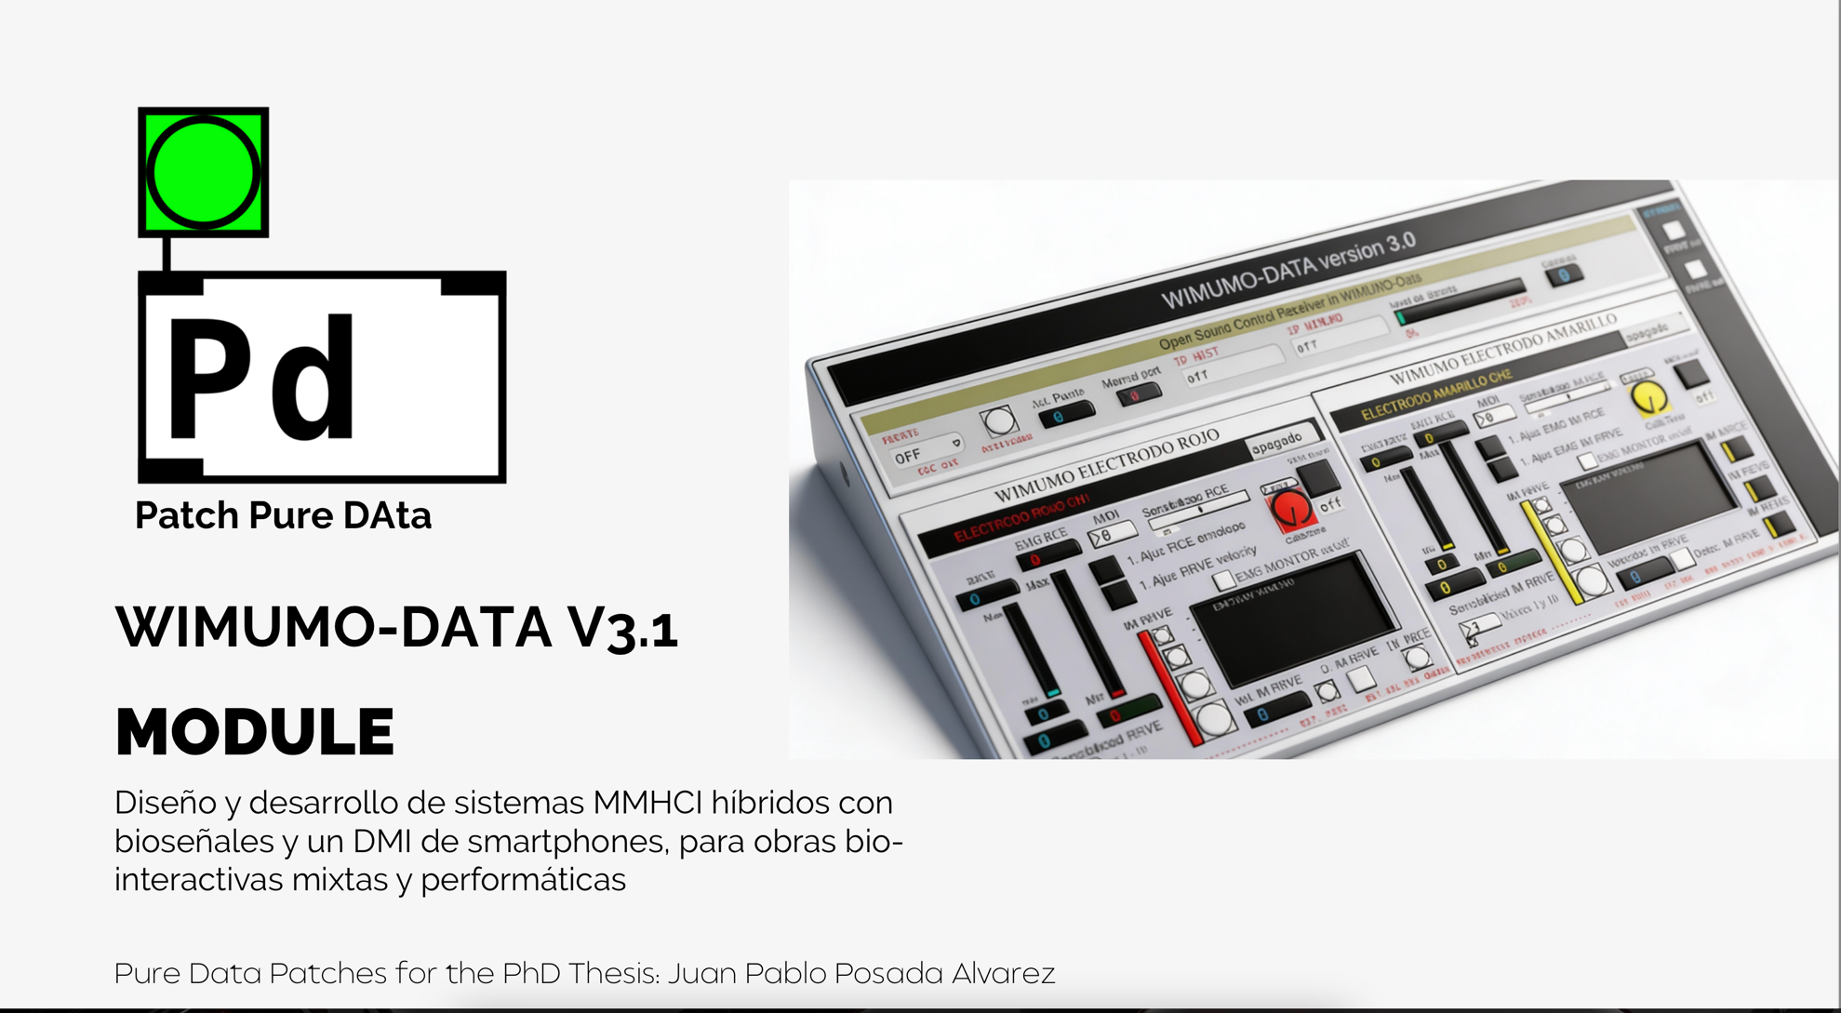

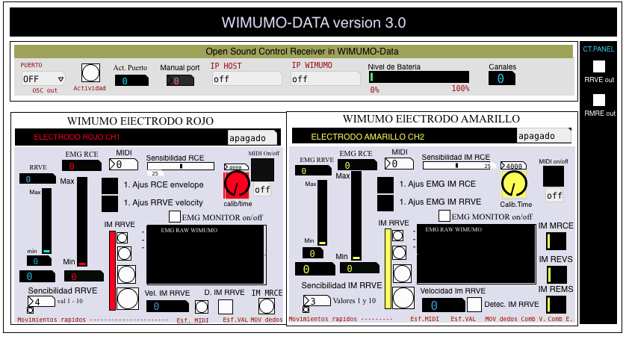

A Reception Section
of data C Panel
OSC WIMUMO Control

D Canal 2
B Canal 1 Right electrode
Left electrode

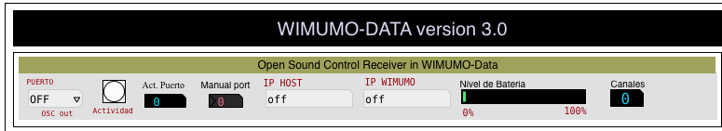
Section A

1

2

3 4 5 6 7 8

It is important to note that the channel 2 module includes the synchronization IMs on channels with two additional outputs for this data. The module's operations guide is set out in detail below, and for ease of reading, it is divided into sections.

    - Port: This parameter allows you to adjust the number of communication ports, which must match the one configured on the WIMUMO board to ensure a stable connection. Both the port and the IP address remain fixed once established. If modifications are required, the WIMUMO SP8232 board will need to be reconfigured using the appropriate procedure.
    - Activity: This bang-type element is triggered when detecting data reception using the OSC protocol on PD. Its primary function is to serve as a connection status checker during the module initialization process.
    - Actport: Displays the numerical value of the port used by the WIMUMO device for sending data. This value must correspond exactly to the value configured in the Port parameter (paragraph 1) to ensure two-way communication.
    - Manual Port: Provides the ability to manually modify the number of communication ports in case specific settings are required, allowing advanced customization of connection parameters.
    - IP Host: Displays the IP address assigned to the receiving computer for the data transmitted by the WIMUMO system. This information is essential for configuring networks in distributed communication environments.
    - WIMUMO IP: Indicates the IP address of the WIMUMO device required for advanced configuration procedures. To access the administration interface, the user must connect to the network called WIMUMO 026 and enter the address 192.168.0.2 in a web browser.
    - Battery Level: Represented by a slider, this element provides a graphical display of the percentage of charge remaining in the device's battery, allowing real-time monitoring of the power status.
    - Channel: Displays the number of channels currently active on the WIMUMO device, providing critical information about the system's operational capability at a given time.

Section B
6
1 7
2 8
3 9
10
4 11
5
12
13 14 15

      - EMG MET: This slider shows the value of the isotonic contraction of the monitored muscle. The measurement ranges are automatically adjusted during the calibration phase of the envelope, allowing for accurate quantification of muscle effort.
      - EMB RFV: This slider reflects the isotonic contraction rate of the muscle analyzed. The values are normalized through the calibration process, ensuring a reliable representation of muscle dynamics.
      - Ajus. CEMS and RFV: Activating this button initiates the calibration procedure for the envelope and shrinkage speed parameters. To ensure optimization tailored to the user's physiology, it is recommended to run the sequence twice. During the process, a sound guide will indicate the right time (after an earcon sound) to perform the desired muscle contraction.
Validation Conditions:
If the minimum value recorded is 0, the calibration must be repeated.
In the case of RFV, if the values exceed the operating ranges, the system will issue an audible alert indicating the need for readjustment.
      - Minimum IM Values: These boxes show the minimum level of background noise in the system. High values may indicate electrical interference or poor connections, so it is recommended to check the integrity of the electrodes and the user's grounding with WIMUMO.
      - RFV Sensitivity: This parameter regulates data density filtering, directly influencing shrinkage rate detection. A higher value increases filtering, reducing noise, but potentially increasing latency. The adjustment range ranges from 1 (minimum filtering) to 5 (maximum filtering).
      - Channel On/Off Indicator: Indicates whether the selected channel is active or inactive, providing a quick visual reference of the system's operational status.
      - CEMS sensitivity: Determines the density of the data stream and the reduction of variability in the EMG signal. High values apply greater filtering, decreasing unwanted fluctuations, but slightly increasing latency in the response.
      - MIDI on/off: This toggle allows you to temporarily suspend sending MIDI data to PMson without affecting the internal operation of the module. EMG signal processing is still active, but without MIDI transmission.
      - Calib. Time: Using this rotary control (knob), the duration of the calibration interval for each IM is adjusted. The count starts with a designed sound and ends after the configured time, allowing the capture window to be customized according to the user's needs.
      - EMG monitor: When activated, this mode allows the EMG signal to be displayed in real time, represented in millivolts per unit of time. It is useful for verifying signal quality and detecting potential artifacts.
      - EMG display: Displays the waveform of electromyographic activity, color-coded according to the associated measuring electrode. This visualization facilitates qualitative analysis of the signal.
      - IM MET: This indicator is triggered when the system identifies an IM MET, signaling a synchronous muscle contraction event.
      - IM RFV Levels: This column allows you to view IM RFVs. It is subdivided into levels depending on the speed detected.
      - Vel IM RFV: Displays the calculated value of isometric contraction velocity, expressed in milliseconds derived from EMG signal processing.
      - IM RFV: Triggered when an IM RFV event is detected on the corresponding channel, confirming the detection of rapid muscle movement.
Section C and D (only additional channel controls are exposed)

1
2

3
4
5
6

          - RFV out: Enabling this checkbox disables sending MIDI data
          - RMEM out: Enabling this check box disables sending MIDI data from Repetitive Effort Motion Response.
          - Space for new implementations in the module.
          - IM MET: IM MET Activation Visualizer
          - IM SVE: IM SVE Synchronous Activation Visualizer
          - IM SRM: IM SRM Synchronous Activation Visualizer

The module is connected as follows:
Channels 1 and 2:
- Outlet 1-4: IM RFV Value Output, Each output provides activation binary values for each of the effort and contraction velocity levels.
- Outlet 5: Continuous output of IM CEMS values in MIDI values. Each output provides values in a range from 0 to 127,
- Outlet 6: Continuous output of raw values from IM CEMS.
- Outlet 7: Output of filtered IM RMRE values from the raw signal in Millivolts
Channel 2:
Outlets 1 -7: Similar to Channel 1 for Channel 2
- Outlet 8: Binary Value Output of (0, 1) for REVS Converged IMs
Outlet 9: Binary Value Output of (0, 1) for REMS Converged IMs

